Newsletter Term 1
Wk 2 2023

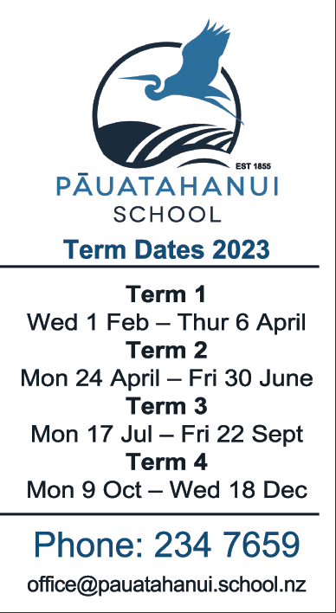

Important Dates
Term 1
14/15 Feb Parent teacher Interviews
16 Feb Board of Trustees Meeting (from 6.30pm in the staffroom)
22 Feb 5.00pm Info evening for year 5/6 camp
6 Mar Powhiri
13 – 15 Mar El Rancho Camp for year 5/6 students

Term 2 starts on the 24th of April

Friday, 10th February 2023

Kia ora e te whānau.

Meet the teacher:

A reminder that next Tuesday 14th February (3.15pm to 6.30pm) and Wednesday 15th February (3.15pm to 5.00pm) you will have the opportunity to book a time to meet your child’s teacher. The purpose of these meetings is for you to share information about your child and to set some shared expectations with their teacher. To help guide this conversation a “Home learning for caregivers” sheet has been sent home with all children today. We would really appreciate it if you were able to spend some time filling this out as it will provide teachers with valuable information about your child. Teachers will be able to share information about how the class and hub will operate this year.

To book a time please go to Meet the Teacher or scan the QR code

Caregivers contact form

A print out of all your contact details and your emergency contacts has been sent home. Thank you to everyone who has already sent theirs back to school if changes are required. If you haven’t done this yet, can you please do it asap as the office is in the process of updating the contact and emergency contact details.

Community help with parking

A friendly reminder that the turning bay outside the school is a place to turn around and to pick children up who are waiting there. It is not a place where you can park and leave your car and walk up to school. I know that other members of the public do not follow these guidelines, but as a school community we need to do the right thing. We also need to be considerate to our neighbours and not park over their driveways.

Sickness

Covid - We have had few students who have been away from school due to having covid. In case you are unsure of the up to date guidelines around covid:
- If your child tests positive for covid they must isolate for 7 days
- Household contacts do not need to isolate. Instead they must test negative everyday for 5 days
- If your child is unwell, please do a covid test

If you require covid tests, we have supplies here at school you can have. If you need some, please ask at the office.

Tummy bugs – Just a friendly reminder that tummy bugs are highly contagious, therefore the advice from the public health board is to keep children at home for 48 hours after the last episode of vomiting or diarrhoea.

Raukawa Camp

Rooms 6, 7 and 8 will be attending El Rancho Camp on Monday 13th March to Wednesday 15th March. The teachers are well into planning this camp and it promises to be a an awesome experience for the kids. Thank you to everyone who offered to help at camp. We now have enough parent helpers for the camp.

Ngā mihi
Caine Webster - Principal

FROM THE OFFICE

Lucky Book Club
Can we please have all orders back in the office by next Thursday the 16th of Feb.
You can also order and pay online through the Book Club Loop app.

Tainui HUB
(Rooms 1, 2)
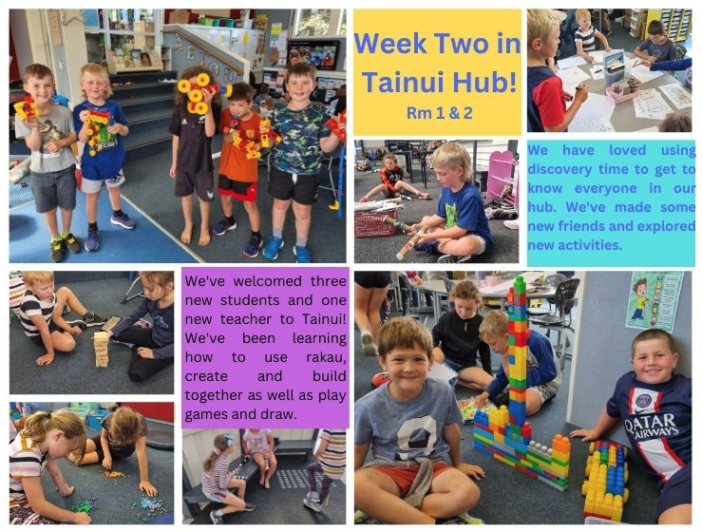

RAUKAWA and WHITIREIA HUB
(Rooms 6, 7, 8, 9 AND 10)

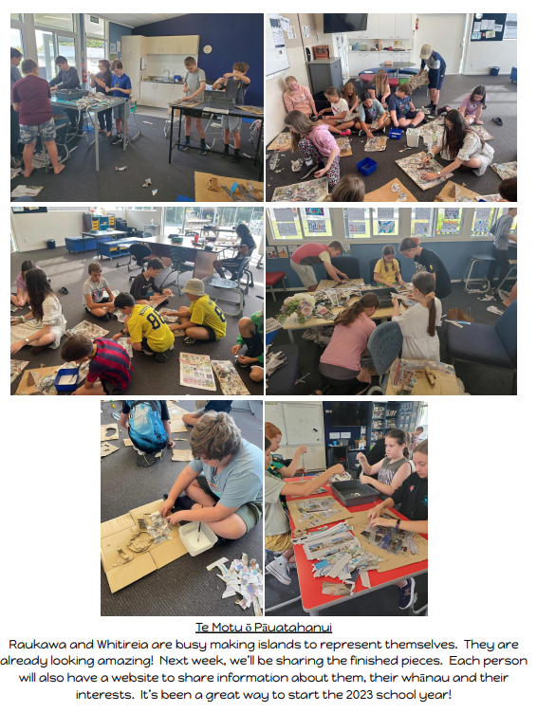

KAWHIA HUB
(Rooms 3, 4 and 5)

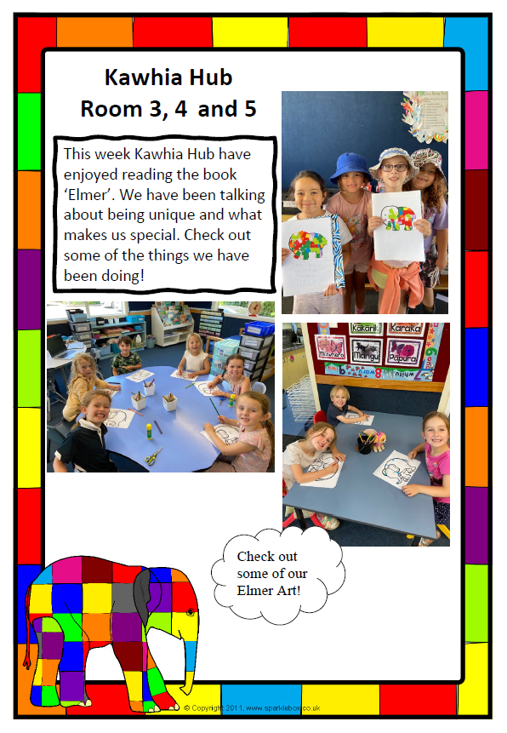

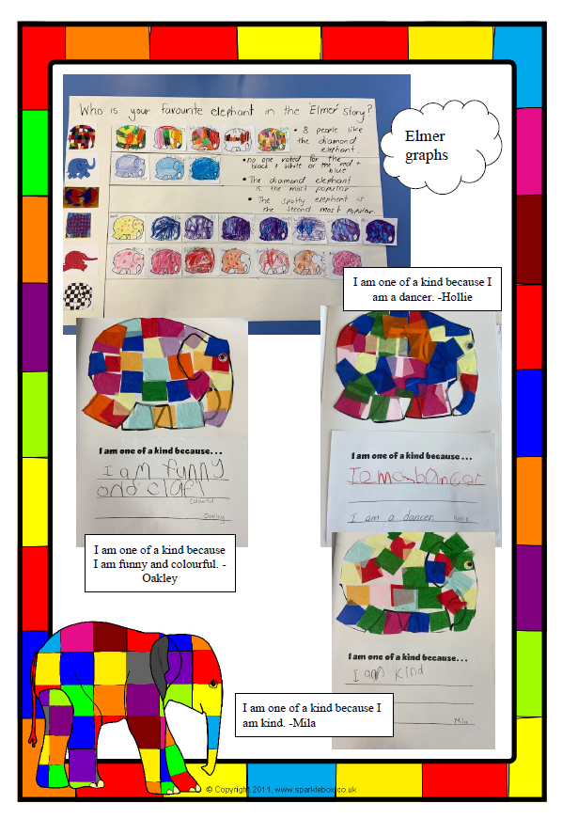

THANK YOU VERY MUCH TO OUR LOYAL SPONSORS WHO HELP IN MANY WAYS
PLEASE CONTACT THE OFFICE IF YOU WOULD LIKE TO ADVERTISE HERE
office@pauatahanui.school.nz

